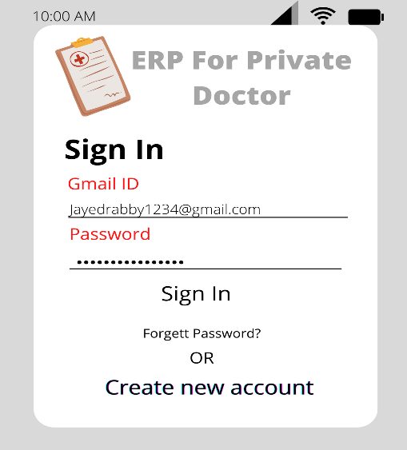 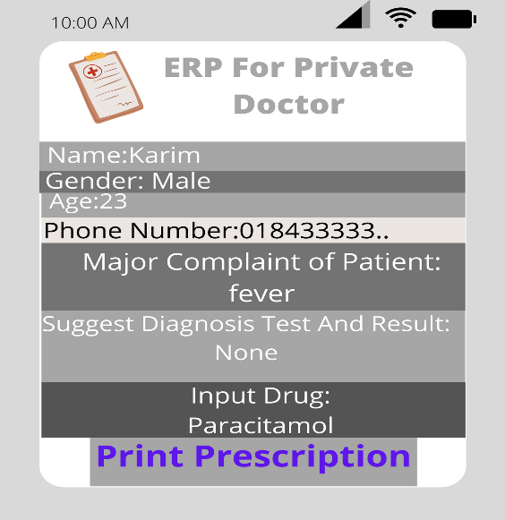 _________________________________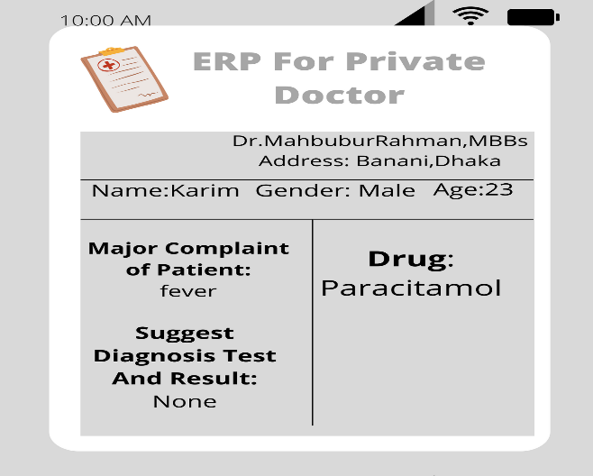

**Mock Design**